Harvest

## Multi-Crop Reaper

**Category:** Harvesting

**Tag:** PTO Operated Harvesting

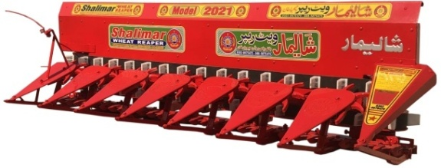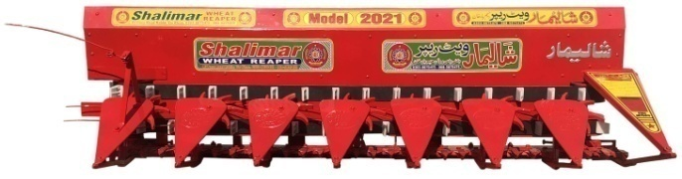

## Description

A tractor mounted PTO operated multi-crop front reaper machine is Intermediate technology between manual and harvester. It is a unique harvesting equipment that reaps the crop and lain it down gently on the ground in form of window. It has continuous belt conveyor with overhead reel & reciprocating cutting bar. This modern equipment ensures 100% recovery of straw with negligible amount of grain loss at an efficient low cost of operation. It is most appropriate for wheat, barley, oat, rice, sorghum, sesame and similar crops.

|  |  |  |
| --- | --- | --- |
| Specifications | | |
|  | Chain Reaper | Belt Reaper |
| Capacity | 1 - 1.5 acre / h | |
| Cutting width | 8 feet | |
| Cutting Fingers | 15 | |
| No. of blades/ knives | 29 | |
| Length | 96’’ | |
| Width | 35’’ | |
| Height | 27’’ | |
| No. of Pullies | 6 | 8 |
| No. of Conveyor Belts | 2 | |
| Weight (Aprox) | 300 KG | |
| Tractor Compatibility | 50    HP | |

## Multi-Crop Reaper Binder

**Category:** Harvesting

**Tag:** PTO Operated Harvesting

## reaper binder.jpgreaper binder 2.jpg

## Description

A tractor mounted multi-crop front reaper binder is entirely used for wheat, barley, oat, rice, sorghum, sesame and similar crops. Multi-crop reaper binder machine consist of two processes, primary task is to cut the crop by pulling it into the front section of machine and then secondary task is to bind the stack and throw it out on the field. This machine performs both processes of stalk cutting and binding at the same time. Its simple and special design makes this machine more accurate and efficient.

|  |  |
| --- | --- |
| Specifications | |
| Capacity | 1 - 1.5 acre/h |
| Material | Steel & Casting |
| Reaping Width | 8 Ft |
| Reaping Height | Adjustable |
| No. of Conveyor Belts | 2 |
| Weight | 350 KG |
| Tractor Compatibility | 40-50 HP |

## Multi-Crop Sorghum Reaper

**Category:** Harvesting

**Tag:** PTO Operated Harvesting

## Sorghum reaper (3).jpgSorghum reaper (1).jpg

## Description

A tractor mounted PTO operated multi-crop sorghum front reaper machine has same working as simple multi-crop reaper machine. It consists of three conveyors to support long height crops such as sorghum & others.

|  |  |
| --- | --- |
| Specifications | |
| Cutting width | 8 feet |
| Cutting Fingers | 15 |
| No. of blades/ knives | 29 |
| Length | 96’’ |
| Width | 35’’ |
| Height | 42’’ |
| No. of Pullies | 9 |
| No. of Conveyor Belts | 3 |
| Weight (Aprox) | 370 KG |
| Tractor Compatibility | 50    HP |

## Potato Digger Machine

**Category:** Harvesting

**Tag:** PTO Operated Harvesting

## Potato Digger (2).jpgPotato Digger (1).png

## Description

Potato digger is a modern equipment to dig potatoes from fields in a speedy way without any difficulty. Here, Shalimar offers a digger which is much durable than others. It required almost no maintenance and extremely simple to operate. It is fabricated of quality tested raw materials that makes it tough and robust. Every model is being tested against various parameters by our quality controllers before dispatching it.

Shalimar potato digger is used to dig potatoes that are cultivated on both furrows and flat lands. This digger have negligible damaging ratio which improve the quality and storage of potato. It digs potatoes and partially separates the tubes from soil and place them on soil surface for subsequent picking.

|  |  |
| --- | --- |
| Specifications | |
| Capacity | 400 - 600 KG |
| Material | Steel |
| Drive Through | PTO Operated |
| Digging Depth | 10'' |
| Working Width | 3.5 - 4.5 Ft |
| Operating Speed | 2 - 3 kmph |
| Labour | No Labour Required |
| Tractor Compatibility | 40-65 HP |